Troll on the net - testing the vulnerability of different networks structures on misinformation

Abstract: Internet trolls are a powerful instrument for spreading misinformation. A troll can be an algorithm that sends a predetermined message to the network and works on the principle: "Repeat a lie often enough, and people will believe it". This study uses a modified DeGroot model of social learning to test the network's vulnerability to messages spread by such trolls. In the study, random graphs generated in a Monte Carlo simulation are infected by a troll placed in a random vertex. The number of interactions needed to fully identify with the troll's message by all network participants will measure the vulnerability of the graphs on misinformation. Multidimensional Scaling and Random Forest machine learning methods applied to data from Monte Carlo simulation will determine which graph and vertex statistics are the best predictors of the network's vulnerability to misinformation. We found that the features of the troll are much stronger predictors than the characteristic of the network.

Keywords: network; troll; misinformation; graph; Monte Carlo; Multidimensional Scaling; Random Forest

Introduction
Artificial intelligence, such as ChatGPT as well as political pressures, are global threats to social learning mechanisms due to the fake news and misinformation spread by the internet. For a long, reaching a consensus or building wisdom through social learning was theoretically explained with the DeGroot model (1974). Even if this model was developed in many directions, no simple modification still shows how the social network behaves influenced by trolls. This paper develops the DeGroot model by adding the troll to the social network and observing how the system behaves. In our approach, a troll is understood as an agent with non-changing beliefs and impacts other agents' beliefs. It influences at least one other agent and only believes in himself, i.e., does not absorb messages from others. This small change demonstrates how the entire social network inevitably takes the position of a troll, regardless of other agents' opinions. Instead of reaching a consensus through social interaction, this modification of DeGroot's model demonstrated the propaganda principle that a lie often repeated enough becomes the truth.
This theoretical model has profound practical implementations as it shows how the network of social connections degenerates and everyone takes over the troll's narrative. It is an argument in the discussion of Karl Popper's paradox of tolerance: "... unlimited tolerance must lead to the disappearance of tolerance" (Popper, 2012). It supports the discussion on whether we should be intolerant of the intolerant, and what limitation in the flow of information in the network should we accept?
This paper presents unexpected theoretical and practical findings and suggestions which can be used in analyzing the problem of the troll on the net. First, introducing such a small change in the original model violates the integrity of the model and repeals one of the fundamental assumptions. There was a need to determine whether this repealing affected the convergence of the results. Secondly, the simplicity of this model is a huge asset as it allows for simulating the influence of a troll on the network. Converting to the troll's opinion differs for different network structures and the troll's position. A study can reveal which random graphs generated by Monte Carlo simulation are infected by a troll placed in a random vertex. The number of interactions needed for all network participants to fully identify with the troll's message will measure the network's sensitivity to misinformation.
The remainder of the paper is as follows. Section 1 presents theoretically the DeGroot model before and after introducing a troll. Section 2 presents the design of the Monte Carlo simulation study and its further analytics based on machine learning algorithms: multidimensional scaling and random forest. Section 3 presents the outcomes of the simulation, showing which graph and vertex statistics best predict network susceptibility to misinformation. Section 4 formulates the conclusions. The appendix presents the measures used in network analysis. Online resources prepared by Authors (2023) allow for own experiments using the developed model.

1. Consequences of placing a troll in the DeGroot model
The problems of fake news, misinformation on the web and Internet trolls concern each of us. Living in a post-truth society can generate huge economic and social costs. Rough estimates of the total cost of misinformation and fake news were $78 billion in 2018 (Brown, 2019). Recently, a lot of theoretical work and empirical research on these issues has been published (Destiny Apuke & Omar, 2020; Rubin, 2019). Even if the results of empirical works (as the above cost estimation of $78 bln) are commonly easy to assimilate, the theoretical models are much less understandable. They are based on very complex issues from advanced graph theory (Tsantarliotis et al., 2016), econophysics models (Galam, 2002) and agent modelling (Gausen et al., 2021). However, the same can be done with a simpler, but powerful DeGroot model of social learning (DeGroot, 1974). This paper shows how to assemble a troll into this model and what are its consequences.

The original DeGroot model of social learning
Usually, the DeGroot model is presented in matrix notation. However, the natural way of representing how society is structured is through graphs, where the social network is represented by two parts – agents and interactions between them (Newman, 2003). The matrix can be easily converted to a directional graph. Consider $N=\{1,2,…,n\}$ agents or nodes interacting with each other – as in the social network, in the discrete time $t∈$ℕ. The interactions are determined by n × n non-negative interaction matrix W:

W = $\left[\begin{matrix}w_{1,1} & ⋯ & w_{1,n} \\ ⋮ & ⋱ & ⋮ \\ w_{n,1} & ⋯ & w_{n,n}\end{matrix}\right]$ | (1)

where for each agent $i, j ∈\{1, …, n\}$ we have $w_{ij}≥0$, while the belief (opinion) vector is x = ($x_{1},x_{2},…,x_{n})$ $∈[0,1]^{n}$. For the simplicity of calculations and interpretation, the interaction matrix W is row-standardised to 1 (values in each row sum up to 1). The values in the W matrix represent how big is the influence of one agent on another one, e.g. $w_{ij}=\frac{1}{3}$ means that agent i listens to agent j with strength $\frac{1}{3}$. The matrix does not change over time. The beliefs are updated by taking the weighted average of current beliefs, where weights are given by the strength of influence, such that beliefs in time t+1 are equal to the product of the interaction matrix and opinion vector at time t, as presented in (eq.2):

$$x\left(t+1\right)=\left[\begin{matrix}w_{11} & ⋯ & w_{1n} \\ ⋮ & ⋱ & ⋮ \\ w_{n1} & ⋯ & w_{nn}\end{matrix}\right]x\left(t\right)=Wx\left(t\right)$$ | (2)
and consequently

$$x\left(t+1\right)=W^{t}x\left(1\right)=W^{t+1}x\left(0\right)$$ | (3)

DeGroot (1974) proved that if the interaction matrix W is strongly connected and aperiodic, then beliefs converge, and consensus is reached. It means $\lim_{t→∞}{x\left(t\right)}$ = x, where $x_{i}=x_{j}$ for every i and j. The network is strongly connected if every agent influences directly or indirectly every other agent. The network is aperiodic if the greatest common divisor of all the lengths of the simple cycles in the corresponding network is 1 (Jarvis & Shier, 1999).
Let us illustrate all of this by example, taking W as follows:

$$W =\left[\begin{matrix}\frac{1}{3} & \frac{1}{6} & \frac{1}{2} \\ \frac{1}{3} & \frac{2}{3} & 0 \\ 0 & \frac{1}{6} & \frac{5}{6}\end{matrix}\right]$$ | (4)

It is shown that Agent 1 (row 1) listens to himself (column 1) with a strength $\frac{1}{3}$and to Agents 2 and 3 (columns 2 and 3) with a strength $\frac{1}{6}$ and $\frac{1}{2}$ respectfully. His beliefs will be the weighted average of beliefs of other Agents in previous time t. Agent 2 listens only to Agent 1 (value $\frac{1}{3}$) and himself (value $\frac{2}{3}$). Agent 3 listens mostly to himself (value $\frac{5}{6}$) and somehow to Agent 2 (value $\frac{1}{6}$). The W matrix is aperiodic because everyone listens to themselves which brings the common divisor to 1. The matrix is also strongly connected because Agent 1 influences Agent 2, who influences Agent 3, who influences Agent 1 - so everyone is influenced by somebody.
Then let us consider the given beliefs vector:

x(0) =$\left(\begin{matrix}\frac{1}{2} \\ 0 \\ 0\end{matrix}\right)$ | (5)

It shows that Agent 1 is somehow ($x_{1}\left(0\right)=\frac{1}{2}$) convinced to some point of view, e.g. he believes that the earth is flat, whereas Agents 2 and 3 are sure that it isn’t ($x_{2}\left(0\right)=x_{3}\left(0\right)=0$). Following the DeGroot model of updating beliefs, one may get the vector of beliefs in period 1 x(1):
$$x(1) = Wx(0) = \left[\begin{matrix}\frac{1}{3} & \frac{1}{6} & \frac{1}{2} \\ \frac{1}{3} & \frac{2}{3} & 0 \\ 0 & \frac{1}{6} & \frac{5}{6}\end{matrix}\right]\left(\begin{matrix}\frac{1}{2} \\ 0 \\ 0\end{matrix}\right)=\left(\begin{matrix}\frac{1}{6} \\ \frac{1}{6} \\ 0\end{matrix}\right)$$ | (6)

After the first exchange of opinions, Agent 1 is less sure ($x_{1}\left(1\right)=\frac{1}{6}$). Agent 2 changed his opinion and now believes with strength $\frac{1}{6}$ and only Agent 3 didn’t change his beliefs. In time=2 the process of updating beliefs is repeated and yields:
$$x(2) = Wx(1) = \left[\begin{matrix}\frac{1}{3} & \frac{1}{6} & \frac{1}{2} \\ \frac{1}{3} & \frac{2}{3} & 0 \\ 0 & \frac{1}{6} & \frac{5}{6}\end{matrix}\right]\left(\begin{matrix}\frac{1}{6} \\ \frac{1}{6} \\ 0\end{matrix}\right)=\left(\begin{matrix}\frac{1}{12} \\ \frac{1}{6} \\ \frac{1}{36}\end{matrix}\right)$$ | (7)
Finally, in an infinite period, one gets:
$${\lim_{t→∞}{x\left(t\right)}= \lim_{t→∞} W}^{t}x\left(0\right)=\left(\begin{matrix}\frac{1}{12} \\ \frac{1}{12} \\ \frac{1}{12}\end{matrix}\right)$$ | (8)

where the consensus is reached. It means that after enough time all agents share the same opinions and, in this example, they are convinced at $\frac{1}{12}$ which is about 8.3%. Fig.1 visualizes the convergence (Fig.1b) of beliefs of the initial network (Fig.1a) and the consensus reached (Fig.1c).

Figure 1: Convergence of beliefs in the DeGroot model: a) initial state, b) convergence process, c) final state
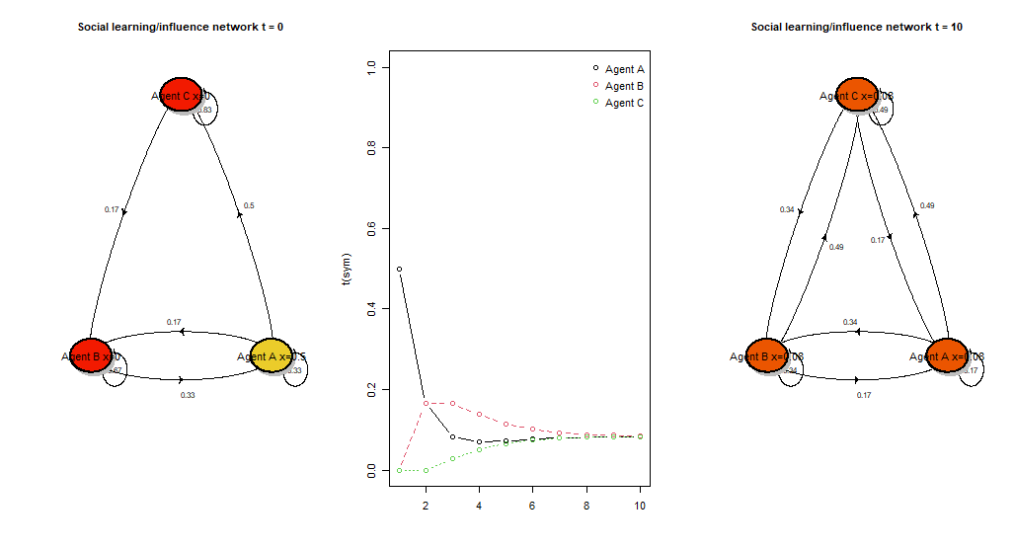
Source: Own work

It is worth noting that the network of connections after n iterations in this model thickens, new links are created, and finally, the graph of connections will be full, where each agent affects, to a greater or lesser extent, every other agent. It is a social learning model where collective knowledge arises as a consensus process.
Modern computational microeconomics uses this model to visualize the formation of collective knowledge when explaining the determinants of the equilibrium price in the market. It was tested as an alternative to the Walrasian tâtonnement mechanism (Joyce, 1984). In this approach, the prices arise due to the interaction between buyers and sellers and are not imposed by an auctioneer external to the market. The parameters of the interaction matrix determine the market power of the agents.

The modified DeGroot model of social learning with the troll
An important modification of the DeGroot model is by introducing an agent who is not influenced by anybody, which is the core of this paper. This agent does not update his beliefs through interactions with other agents, but others adopt his beliefs. We call this type of agent an ‘algorithmic troll’. This is because we assumed that only an algorithm can always generate the same information and not be influenced by the opinions of others, even in a minimal way.
Introducing a troll into the model results in relaxing the assumption that the interaction matrix is strongly connected in the first step. Below we examine how weakening this condition affects the convergence of the results of social interactions. We also check whether the other Agents will always assimilate the point of view of the troll.
Let troll be the Agent $Z$. The troll must influence at least one other agent and is not influenced by anybody else. It means that for each Agent $i ∈\{1, …, n\}$ we have $w_{Zi}=0$, if $Z≠i$ and $w_{Zi}=1$ when $Z =i$. Additionally, we suppose that by excluding the troll (removing column and row $Z$) the network would become strongly connected and all agents listen to themselves. Following the DeGroot model of updating beliefs one gets the following solution.
Let us consider the n × n nonnegative interaction matrix W. Without the loss of generality, one can assume that the troll has the last column denoted with index Z. Because in each row the values add up to one and the last row has presented structure (0, 0, …, 0, 1), one can calculate interaction matrix in infinite time t W^{t}:

$\lim_{t →∞}{W^{t}=}$ $\left[\begin{matrix}0 & 0 & ⋯ & 1 \\ 0 & ⋱ & 0 & ⋮ \\ 0 & 0 & 0 & 1 \\ 0 & 0 & 0 & 1\end{matrix}\right]$ | (9)

To get the result (9) one can interpret W matrix as a right stochastic matrix, where each value $w_{ki}$ represents the probability of going from state k to state m. For all agents except troll, it is possible (with probability p_{ij}>0) to go from each agent to another in n-1 steps, as the matrix is strongly connected and there are n agents.
Because it is possible to go to the state z from at least one other state, as someone listens to troll, it is always possible to go to the state z in n steps with probability higher or equal to some fixed value p_{z} >0. One can obtain this value by taking the minimum probability of going from all the other states to state z. Once getting into state z, one is not able to escape it due to the structure of the last row of the interaction matrix, being (0, 0, …, 0, 1) and representing the troll.
Now let us group each of n iterations separately, and define A₁ as an event that an agent will be at least once at state z in the first n iterations. Parallelly, A₂ is an event that an agent will be at least once at state z within second n iterations, and so on. One gets an infinite series of events A_{i} where P(A_{i})$≥p_{z}$ > 0. From that, it easily follows that probability that an Agent i goes into state z at some point is equal to one – otherwise, it would not happen in all A_{i}, which has a probability less or equal than $\lim_{n →∞}{{(1-p_{z})}^{n}= 0.}$
So, one can use a nonnegative distribution (π₁(t), π₂(t), …, π_{n-1}(t), π_{z}(t)), representing the probability that at time t we are in state i with probability π_{i}(t). Of course π₁(t)+ π₂(t)+ …+ π_{z}(t)= 1 for each t, and because we will end up in state z with probability 1 we have:

$$\lim_{n →∞}\left(π_{1},π_{2},…,π_{n}\right)W^{n}=(0, ..., 1)$$ | (10)

what gives the result as in (eq.9). This makes that in our model, in the long run, the consensus is reached, and all agents share the trolls’ opinion, because:

$${\lim_{t→∞}{x\left(t\right)}= \lim_{t→∞} W}^{t}x\left(0\right)=\left[\begin{matrix}0 & 0 & ⋯ & 1 \\ 0 & ⋱ & 0 & ⋮ \\ 0 & 0 & 0 & 1 \\ 0 & 0 & 0 & 1\end{matrix}\right]x\left(0\right)$$ | (11)

In the example below we placed troll (in the last row) into the previous (eq.4) belief matrix W:

$$W =\left[\begin{matrix}1/3 & 1/6 & \begin{matrix}1/3 & 1/6\end{matrix} \\ 1/3 & 2/3 & \begin{matrix} 0 & 0\end{matrix} \\ \begin{matrix}0 \\ 0\end{matrix} & \begin{matrix}1/6 \\ 0\end{matrix} & \begin{matrix}\begin{matrix}5/6 \\ 0\end{matrix} & \begin{matrix}0 \\ 1\end{matrix}\end{matrix}\end{matrix}\right]$$ | (13)

while in the vector of beliefs x(0) the troll has a belief equal to 1:

x(0) =$\left(\begin{matrix}1/2 \\ 0 \\ \begin{matrix}0 \\ 1\end{matrix}\end{matrix}\right)$ | (14)

The troll only believes itself (value 1 in the last row on the diagonal of the matrix) and influences one of the agents (first line) who split its attention between the troll (1/6) and other agents (5/6). The matrix is aperiodic because everyone listens to themselves (non-zero-diagonal) which brings the common divisor to 1. The matrix is not strongly connected because no one influences the last agent – the troll.

Figure 2: Convergence in the DeGroot model with troll
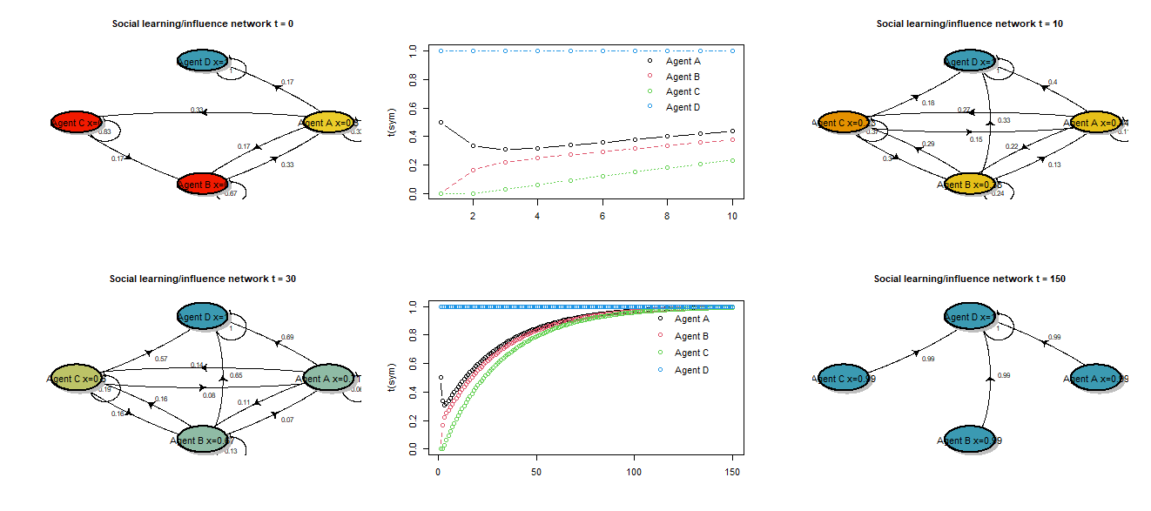
The upper panel shows the transition from t=0 to t=30, while the lower panel shows changes between periods t=30 and t=150. Graphs illustrate relations between agents, while line charts show the convergence of beliefs.
Source: Own work

Fig.2 shows that all agent's beliefs converge to the troll's belief. This convergence can be divided into two stages: in the first one, new troll connections are made and a complete graph is formed, while in the second stage, this graph becomes degenerated. The influence of other agents on each other decreases and the troll's influence on others increases. In infinity, only the troll influences other agents.
This model could be taken as a curious example of not fulfilling one of the model assumptions. However, it reflects well the misinformation problem, embedded in the psychological illusory truth effect and political and negotiation tactics - salami slicing. In a series of experiments, psychologists showed that people can take a false statement for true if it is repeated frequently enough. This is true even if they initially knew the correct statement but were convinced otherwise by repeating the lie (Hasher et. al, 1977; Fazio et al, 2019). This effect has been used in propaganda for a very long time. Said to be Joseph Goebbels' motto "If you tell a lie big enough and keep repeating it, people will eventually believe it” is still ubiquitous in contemporary politics, advertising, and social media (Little, 2018).
In psychological research, truth or untruth is a dichotomy of 0 or 1. In social reality, one can only speak of agents' certain levels of belief. In political science and negotiations, there is a technique for changing beliefs called slicing salami (Kwak & Kim, 2020). Negotiators start by asking for small concessions and asking for even more small concessions gradually; bit by bit, they are slowly taking away others' values. In Eastern European countries, the ruling parties associated with the USSR, step by step, liquidated political opponents, and the transition process from democracy to tyranny took several years (Enh, 2010).
In the presented model, if the troll is lying (belief=1), the agents will gradually accept the false statement, even if it is not immediately taken as truth. Exposure to the troll's beliefs makes a steady erosion of non-troll beliefs. The effects are noticeable in the long run. Since the convergence process is different for different networks (graph) structures, a measure of the network's sensitivity to the troll's influence can be defined as the number of interactions needed to make the difference between the troll's and other's views small enough - all agents accepted the troll's views as own within the statistical error limit of 0.005.

2. The simulation model
The following section presents the Monte Carlo simulation of networks with different parameters. We derive a measure of the troll's impact on the network which enables assessing the network vulnerability for being infected by the troll. We analyse which of the statistical characteristics of the graph and the network troll’s node are the best predictors of the network's exposure to infection with fake news/misinformation. A single iteration in Monte Carlo simulation consists of the following steps.
Step 1: Generating a random graph with given parameters: size, probability, troll location. We used a very elastic Erdős-Rényiof graph G_(n,p)(1959, 1960, 1961) to generate different network structures. However, including a troll in this network requires spreading the generation of this structure over several steps.
Step 1a: Creating a random matrix of interactions W. We need a number of agents (N) only. We additionally add a minimum probability which does not change the results but speeds up the simulation as we get rid of too thin networks. The probability of connection p is randomly chosen. The matrix R, representing the strength of available connections, is created by choosing values from a uniform distribution on [0, 1] for each element of the matrix. Then the matrix M is created. This matrix determines whether each possible connection occurs. M equals 1 if j=i and the following distribution for i≠j:

$$M_{ij}=\left\{\begin{aligned}1 with probability p \\ 0 with probability (1-p)\end{aligned}\right.$$ | (14)
By combining both – it is by multiplying the elements that stand in the same place - one gets an W matrix, such that $W_{ij}=R_{ij}⋅M_{ij}.$
Step 1b: Placing a troll in a random place on the network. A troll will be placed in a randomly selected row of the random matrix. In this row value on the diagonal is 1 and off the diagonal is 0.
Step 1c: Verification of strong connections. Convergence in the network occurs when all non-troll agents are at least indirectly connected to each other and when the troll influences them. In this step, we check those properties for the interaction matrix W. It is achieved when agent j influences agent k, directly or indirectly, and thus agent j influences also all agents that agent k influences. This happens whenever in the interaction matrix the agent j influences agent k, what is represented as $W_{kj }>0$ the values from the column k are added to the values in the column j, such that ${W'}_{ij }=W_{ij }+W_{ik }$. The process is repeated for every agent N times because the longest possible path has a length equal to the size of the matrix (N). Finally, we check if the number of zeros that are remained in the matrix W’, which is the matrix after all transformations, is equal to N²-(N-1), as only the troll should not be influenced by others but himself. If the condition is not met, steps from 1a to 1c are repeated.
Step 2: Converting Matrix to an Erdős-Rényiof graph G_(n,p) with a troll. Getting network measures is possible after we convert the interaction matrices into a graph. It is related to the built-in functions of R software. To convert the interaction matrix we create two vectors – one of length n², containing weights of connections, and the second of length 2n² where the odd-valued indices represent the connections FROM the agents, and the even-numbered indices represent connections directed TO the agents. Then the values are rewritten except for those that have the value 0 as there is no connection. After this conversion, we create the graph (e.g. using the graph() function in R).
Step 3: Collecting data and graph and troll’s measures. Having a graph in a standard form one can calculate and collect the statistics relating to the troll’s vertex: degree, page rank, local efficiency, eccentricity, and strength and statistic relate to how the social network is structured: reciprocity, edge density, transitivity, size, and probability of connection. All those measures characterise the graph and will be used in looking for the networks that are most vulnerable to misinformation.
Step 4: Create the vector of initial beliefs. In creating the vector of initial beliefs one uses a uniform distribution for all “standard” agents and the extreme value (0 or 1) for the troll. This means the troll has an extreme belief, and all agents' beliefs tend to it.
Step 5: Collecting a measure of the network's sensitivity to the troll's influence. The final step combines the previous steps into one function. Simulation and updates of beliefs stop when all the beliefs are close enough to those of the troll such that we recognize all agents as persuaded. Usually, this value will be set at 0.005. The vector of initial beliefs x(0) created in Step 4 is multiplied on the left by the interaction matrix W and gives the beliefs vector at time t=1 – this is the basis for repeated multiplication. It resembles the Markov Chain process with slight modification in that the matrix is being multiplied by the vector from the right side. The process is performed as long as all the agents reached a consensus - in this case, they are almost fully persuaded by the trolls’ propaganda. The most important information is the moment when the update stops due to all agents being persuaded. This happens when the maximum value of the beliefs vector at time t is greater or equal to the maximum value of the beliefs vector at time t+1. We collected the time needed to reach a consensus. Thus finally, for each simulation, we gathered information on the number of iterations when the simulation stopped, all the inputted parameters and network measures presented in step 3. In the Monte Carlo simulation, steps 1 – 5 were repeated M times to collect data for different graph structures.

3. Results and discussion
The simulation was carried out separately for graphs of different sizes, from 20 to 120 nodes with a step of 20. In each of these simulations, 10’000 graphs were generated. The same parameters were adopted in these simulations: the minimum probability of creating a connection was 0.2, uniform distribution of agent beliefs from the range [0,1]. It was assumed that the troll represents the extremes of belief - a parameter for the troll in the vector $x_{o,troll}=1$. It was assumed that the difference in beliefs of the troll and other agents less than 0.005 means that all agents fully adopt the extreme troll’s beliefs x_{t} ~ [1, 1, 1, ... ,1]. We use a few measures of networks: core dependent variable - network sensitivity to the troll (NStT) expressed as a speed of convergence to the troll’s point of view, explanatory variables related to the network – edge density, reciprocity, transitivity; and explanatory variables related to the troll – degree, strength, page rank, local efficiency and eccentricity (Garlaschelli & Loffredo, 2004; Brin & Page, 1998; Latora & Marchiori, 2001; Latora et al., 2017a,b). Definitions of those measures are in Appendix.

Scalability of results
The first major finding is that when the network size increases, the median and the average network sensitivity to the troll (NStT) measures increase proportionally (linearly) (Fig.3). The network size ranged between 20 - 120 nodes and it yields robust results. The complexity of relationships in a network grows exponentially with the size of the network (and consequently with the number of possible connections in the graph). The number of iterations needed for all agents to adopt the troll's beliefs (NStT) grows linearly. This result may follow the “small world effect” here (Watts & Strogatz, 1998; Watts, 1999). Even a considerable distance and a small number of connections between the agent and the troll can be quickly compensated by the speed of creating a full graph due to interactions between agents. It is worth pointing out, that the linear growth of the network, associated with the exponential growth of complexity, yields the linear growth of the maximum distance from the troll. The obtained scalability of the results should be a subject of deeper analysis – to our knowledge there is no literature on that issue.

Figure 3: Network sensitivity to the troll (NStT) measures vs size of the graph
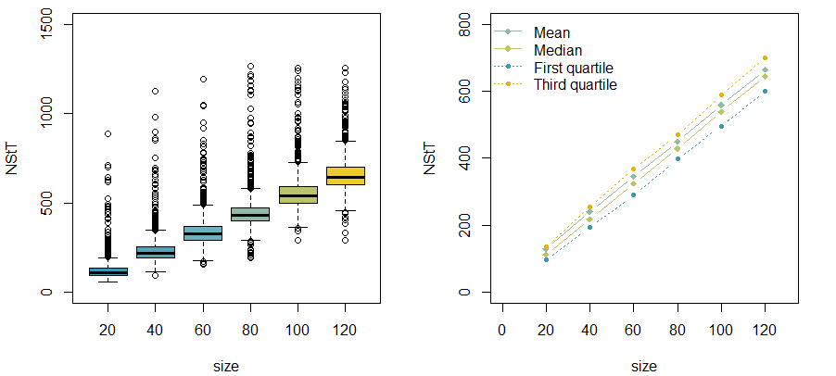
Source: Own work

Multidimensional scaling in tracking mutual relations between variables
Mutual relations between variables can be deeply analysed with the use of Multidimensional scaling (MDS) (Carroll & Arabie, 1998). This replaces typical correlation analysis by offering a distance-based algorithm (instead of covariance-based) which compares pairs of variables as well as all variables as a system. MDS represents graphically the distance matrix between variables represented by circles (Fig.4b) – the closer they are located the more similar to each other they are. On the other hand, the size of the circle illustrates stress per point - how the information load of a given variable differs from other variables – the bigger the size, the more different information (Fig.4a).
It can be seen that the variables that describe the troll's vertex characteristics: degree, strength, eccentricity cluster and their stress per point are large. Only the troll's vertex characteristic page rank is not close to them. Close to the clustered variables is the NStT measure. Variables of edge density and probability of connection overlap each other - both represent similar information. The size variable also is placed differently than others not correlating strongly with any other measure.

Figure 4: Multidimensional scaling (MDS) and stress per point decomposition

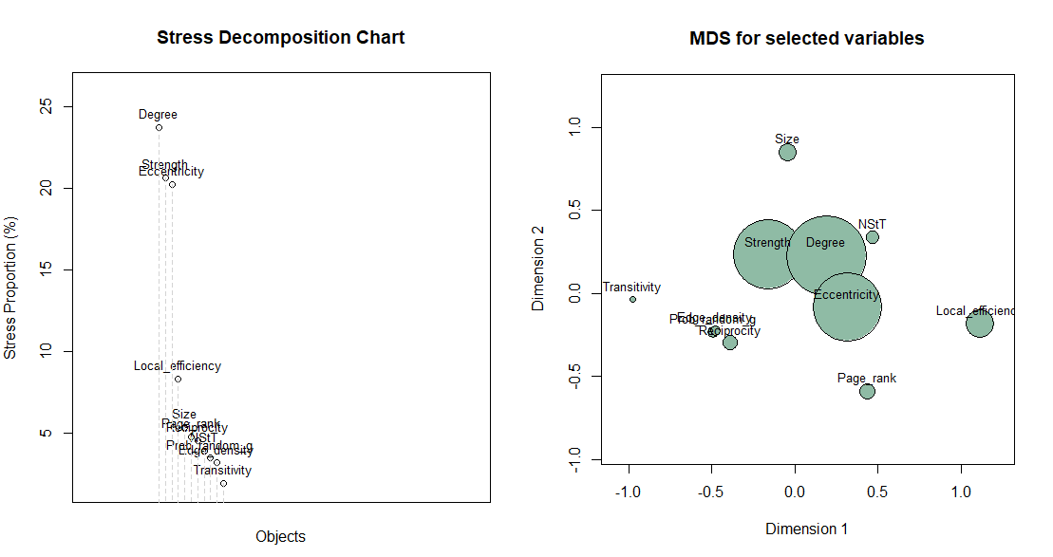
Source: Own work

Speed of convergence to troll (NStT) vs the network features
The core of this research was to check the relationship between network architecture and network sensitivity to the troll (NStT). We observe that the trolls’ vertex measures are strongly related to the time of convergence (more than the agent’s vertex measures). Fig.5 shows the distribution of NStT measures depending on analyzed variables: the probability of connection, edge density, transitivity, and reciprocity – as the distribution looks uniform (no difference in NStT due to values of those variables) we conclude on their poor (and insignificant) relation to NStT (Fig.5a,g,h,i).
The eccentricity measure (Fig.5f) turned out to be almost exclusively equal to 2 (second boxplot), what means that troll and agent are connected by one extra agent (1 means direct connection). It is an interesting result as it shows that in random networks, which represent the relations and social connections it is almost impossible to escape the misinformation, if only this is present at all. In practice, even when one turns off the TV, internet, and radio and avoids newspapers, the conversation with relatives, colleagues or friends who are exposed to media (and trolls) makes the person one step from the troll. It highlights the significance of the analyzed issue. The local efficiency which measures how far are the trolls’ neighbours when the troll is excluded is concentrated in lower values and thus does not play a significant role in analyzing the networks’ susceptibility to the troll. The measures related to the placing of the troll show a nonlinear downward (negative) relation to NStT, which is especially the case of strength that sums all the values of influence of the troll and page rank – a measure used in search engines that calculates the probability of going from one site to another, and to a lesser degree, the trolls’ degree. Further findings support their importance.

Figure 5: Boxplots of NStT (speed of convergence) by the levels of network statistics and the vertex where the troll is: a) probability of random graph, b) strength, c) edge degrees, d) page rank, e) local efficiency, f) eccentricity, g) edge density, h) reciprocity, i) transitivity

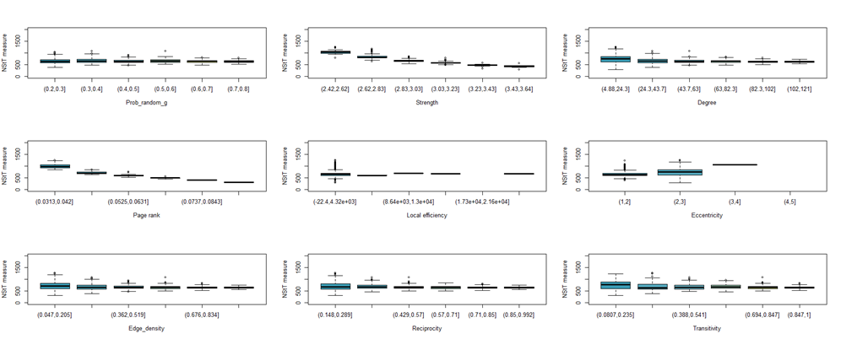
Note: Each combined boxplot has the features of the network (in intervals) on the x-axis and NStN measure on the y-axis. The first row has figures a,b,c; the second row has figures d,e,f; the third row has figures g,h,i. Edge density, reciprocity, and transitivity describe the network, while degree, strength, page rank, local efficiency and eccentricity describe the troll features (vertex where the troll is).
Source: Own work

Fig.6 presents the correlations between measures and NStT. All of them turned out to be statistically significant however, two of those measures, page rank and strength, stand out from others. Their negative correlation with NStT is higher than 0.9. It is also visible in the first column of Fig.6 where the time needed to reach the consensus aligns with great accuracy with those measures’ values. This suggests that the most important factor in determining the network susceptibility is the overall sum of the strengths of troll influence and the quality of placement of the troll measured via page rank measure. It indicates that if one wants to spread disinformation, then one should repeat the lie through the strongest channels.
Other measures such as transitivity, reciprocity, edge density and degree of the troll are also statistically significant, however, the correlations with NStT are lower and range between 0.1 and 0.3. They are highly correlated with each other and bring similar information. They only slightly explain the time of convergence and their variability is high. Especially interesting is that edge density is not as important as expected, and is only slightly relevant which means that it does not matter if the network is dense or rare.

Figure 6: Correlations between NStT and analyzed measures
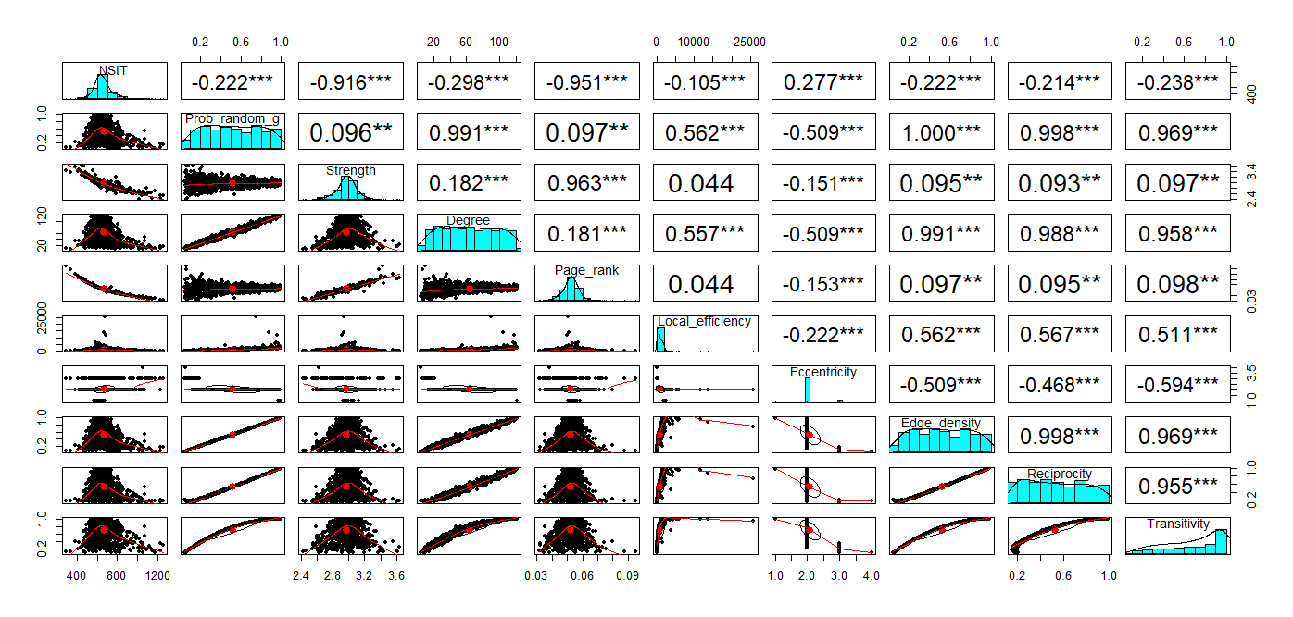
Source: Own work

Prediction based on the machine learning
Due to the non-linear dependencies, the Random Forest (RF) machine learning model was used to identify those characteristics of the network and the troll vertex that have the best predictive ability to classify the networks into two groups: i) with high sensitivity to the influence of the troll - 25% of cases with the lowest NStT value; ii) with medium and weak vulnerability to troll influence - all other cases. As all networks finally were infected by the troll, we are to study in which networks this influence is the quickest. RF model was designed as a binary classifier, which is to distinguish between high-sensitivity networks (1) and other networks (0). RF model considered 3 variables at each split and run 500 trees for each model. The obtained prediction properties of the Random Forest model are very good. OOB (out-of-bag) error was 0.74%, which means that on the testing sample, less than 1% of cases were misclassified (enrolled to the opposite group). In the confusion matrix, the proportion of well- and misclassified cases for value 0 was 4477 to 10, while for value 1 it was 1449 to 34.
The importance of predictors was presented in Fig.7. A mean decrease in accuracy (Fig.7a) represents how much on average the ability of classifying and predicting NStT suffered when certain measure was omitted. The mean decrease in Gini coefficient (Fig.7b) illustrates the influence of the variable on the homogeneity of groups in the random forest. The results clearly show that the PageRank measure has by far the highest predicting power in both cases. The next two positions are taken by the size and strength of a network. It confirms that size plays an important role in characterizing the scale, but there is no important difference between networks that have different sizes, they are just bigger.

Figure 7: Variable importance from the Random Forest model
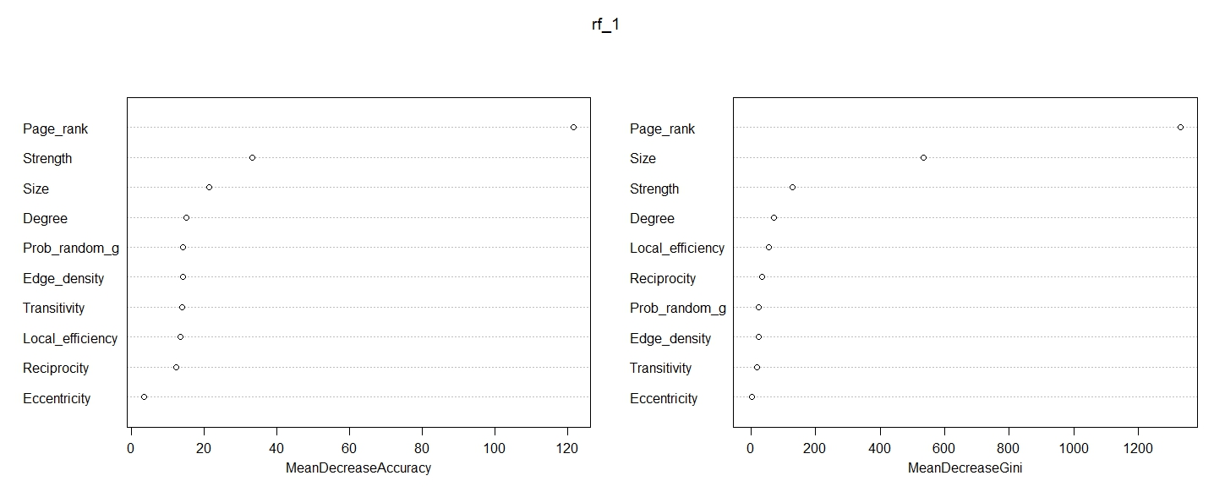
Source: Own work

The partial dependence charts show how relations between variables change depending on their level. They are a good indicator of the strength of explanatory variables in predicting. The graphs indicate the non-linear dependence of dependent variables on explanatory ones. Comparison of partial dependence plots highlights the differences between PageRank, strength, degree, and other measures. The PageRank again is the most effective variable, with a sharp drop at a value equal to 0.12, however, strength seems to perform well too showing nonlinear dependence. Other measures present irregularities.

Figure 8: Partial dependence plots from random forest models
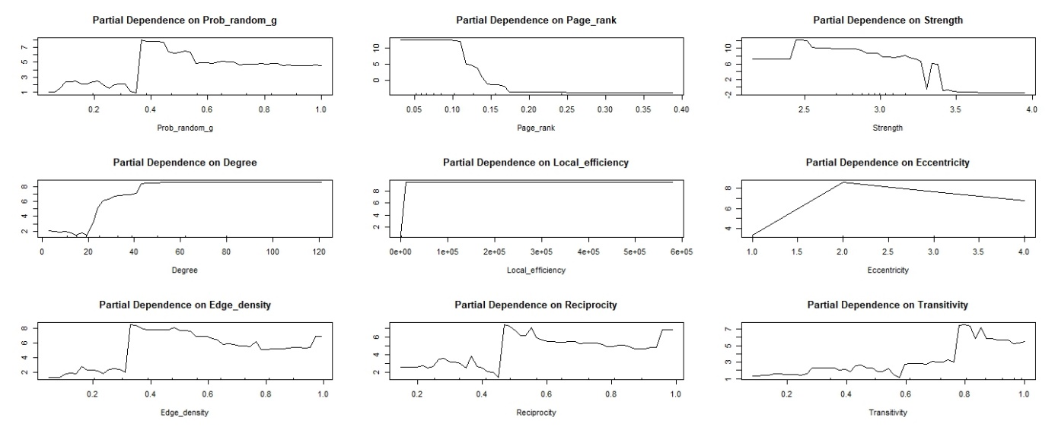
Source: Own work

In general, the network's characteristics such as edge density and reciprocity are much weaker predictors in this classification. The network structure does not play a crucial role in predicting networks’ vulnerability to NStN as the troll's place in the social network explains more.

4. Conclusions and further applications
The presented DeGroot model of social learning with a troll very adequately demonstrates the spread of misinformation in the network. The goal of the study was to find what causes that (social) network fully assimilates the troll point of view. We found that the characteristics of a troll are far more important than the features of a network. The essential characteristics of the troll's vertex (page rank, strength, eccentricity) and the size of the graph are perfect predictors of the network's vulnerability to troll, while the general characteristics of the graph are not as good as predictors.
This study developed an interesting research methodology. First, we run the Monte Carlo simulation of dynamic graphs (that were converging to the state of full persuasion) and collected a huge dataset which included a majority of possible scenarios of how this network behaves. Secondly, we used a Machine Learning classifier (Random Forest) to find which parameters of the network and troll are the most important to predict that the network will converge to a full persuasion state quickly and thus is highly vulnerable to troll propaganda.
It has profound consequences and implementation possibilities in many dimensions. First, this theoretical development is very novel and can be further explored. We see many possible streams of studies, some were described below. It is an interesting proposition of non-atomistic economic models, where society is no more a simple sum of actions of individuals, but forms a network which reveals social behaviours. Secondly, policy implications that can be built based on this model are very serious. The model can predict the behaviour of social networks in ChatGPT environment or non-liberal media. Third, it has also educational value as it can demonstrate well the social environment in a dynamic model context. This model is well documented on the project website (authors, 2023). This website also includes simulations and codes of materials for this and article and didactic materials for the troll experiment on the web.
Further developments are possible. This result encourages further work on creating a system for detecting the threat of an algorithmic troll in the network. The scheme of this system could be as follows: i) creating a Monte Carlo simulation model based on the presented scheme, but more extensive and closer to the behaviour of real social networks; ii) using MC simulation results and machine learning algorithms, creating a model and forecast of network's vulnerability to troll; iii) data describing the real network can be entered to the calibrated model to make a prediction for a real situation; iv) the forecast obtained from the model and the decision tree would indicate a potential threat to the network caused by an algorithmic troll.
We called the troll “algorithmic” because others do not influence it. It is supposed to convey extreme opinions continuously and unreflectively. Currently, the real-life realisation of this concept is ChatGPT and similar AI platforms. It seems that ChatGPT is not “perfect” algorithmic troll as it seems to change its beliefs, which are the aggregation of the knowledge of others, and thus does not represent extreme views (let's hope it will). The structure of the directed graph connecting the ChatGPT (troll) with the users (agents) can resemble a star. When the serious competition of ChatGPT enters the market, it will be more like a hub or multi-star structure. Interestingly, averaging users' beliefs/knowledge becomes the ChatGPT's belief. The algorithmic aggregation of knowledge solves the problem of information overload in the network (Simon, 1990); however, the assumption of heterogeneity of beliefs, which is a condition for forming collective wisdom, is not met (Surowiecki, 2005). Finding a simple model to demonstrate these issues is a possible research development.

Bibliography

Authors (2023), online report and codes.
Brin, S., & Page, L. (1998). The anatomy of a large-scale hypertextual Web search engine. Computer Networks and ISDN Systems, 30(1-7), 107–117. doi:10.1016/s0169-7552(98)00110-x
Brown, E (2019), Online fake news is costing us $78 billion globally each year, ZDNet, https://www.zdnet.com/article/online-fake-news-costing-us-78-billion-globally-each-year/ (accessed 08.06.2023)
Carroll, J. D., & Arabie, P. (1998). Multidimensional scaling. Measurement, judgment and decision making, 179-250.
DeGroot, M. H. (1974). Reaching a Consensus. Journal of the American Statistical Association, 69(345), 118. doi:10.2307/2285509
Destiny Apuke, O., & Omar, B. (2020). Fake News and COVID-19: Modelling the Predictors of Fake News Sharing Among Social Media Users. Telematics and Informatics, 101475. doi:10.1016/j.tele.2020.101475
Enh, A. M. (2010). The Origins of the Communist Rule in Eastern Europe: A Brief History. Journal of International Studies, 6, 114-126.
Erdős, P., & Rényi, A. (1959). On random graphs. Publicationes Mathematicae 6, 290–297.
Erdős, P., & Rényi, A. (1960). On the evolution of random graphs. Publ. Math. Inst. Hung. Acad. Sci, 5(1), 17-60.
Erdős, P., & Rényi, A. (1961). On the strength of connectedness of a random graph. Acta Mathematica Scientia Hungary 12, 261–267.
Fazio, L.K., Rand, D.G. & Pennycook, G. (2019) Repetition increases perceived truth equally for plausible and implausible statements. Psychon Bull Rev 26, 1705–1710. https://doi.org/10.3758/s13423-019-01651-4
Galam, S. (2002). Minority opinion spreading in random geometry. The European Physical Journal B-Condensed Matter and Complex Systems, 25, 403-406.
Garlaschelli, D., & Loffredo, M. I. (2004). Patterns of Link Reciprocity in Directed Networks. Physical Review Letters, 93(26). doi:10.1103/physrevlett.93.268701
Gausen, A., Luk, W., & Guo, C. (2021). Can we stop fake news? using agent-based modelling to evaluate countermeasures for misinformation on social media. In International AAAI Conference on Web and Social Media (ICWSM). https://doi. org/10.36190.
Hasher, L., Goldstein, D., & Toppino, T. (1977). Frequency and the conference of referential validity. Journal of verbal learning and verbal behavior, 16(1), 107-112
Jarvis, J. P., & Shier, D. R. (1999). Graph-theoretic analysis of finite Markov chains. Applied mathematical modeling: a multidisciplinary approach, 85.
Joyce, P. (1984). The Walrasian tatonnement mechanism and information. The RAND Journal of Economics, 416-425).
Kwak, D., & Kim, M. (2020). Trade Negotiations in the Digital Era: The Case of OTT Video Streaming Services. Global Policy, 11, 14-22.
Latora, V., & Marchiori, M. (2001). Efficient Behavior of Small-World Networks. Physical Review Letters, 87(19). doi:10.1103/physrevlett.87.198701
Latora, V., Nicosia, V., & Russo, G. (2017a). Centrality Measures. In Complex Networks: Principles, Methods and Applications (pp. 31-68). Cambridge: Cambridge University Press. doi:10.1017/9781316216002.004
Latora, V., Nicosia, V., & Russo, G. (2017b). Small-World Networks. In Complex Networks: Principles, Methods and Applications (pp. 107-150). Cambridge: Cambridge University Press. doi:10.1017/9781316216002.006
Little, A. T. (2018). Fake news, propaganda, and lies can be pervasive even if they aren’t persuasive. Critique, 11(1), 21-34.
Newman, M. E. (2003). Random graphs as models of networks. Handbook of graphs and networks, 1, 35-68.
Popper, K. (2012) The Open Society and Its Enemies. Routledge. p. 581 (Original work published 1945)
Rubin, V. L. (2019). Disinformation and misinformation triangle: A conceptual model for “fake news” epidemic, causal factors and interventions. Journal of documentation.
Simon, H.A. (1990). Information Technologies and Organizations. The Accounting Review, 65(3), 658–667. http://www.jstor.org/stable/24795
Surowiecki, J. (2005). The wisdom of crowds. Anchor.
Tsantarliotis, P., Pitoura, E., & Tsaparas, P. (2016). Troll vulnerability in online social networks. In 2016 IEEE/ACM International Conference on Advances in Social Networks Analysis and Mining (ASONAM) (pp. 1394-1396). IEEE.
Watts, D. J. (1999). Networks, Dynamics, and the Small‐World Phenomenon. American Journal of Sociology, 105(2), 493–527. doi:10.1086/210318
Watts, D. J., & Strogatz, S. H. (1998). Collective dynamics of ‘small-world’ networks. nature, 393(6684), 440-442.

Appendix 1
Brief description of measures used in the study.

Troll related
- Degree of the troll represents how many agents are directly influenced by a troll in relation to the size of a given social network. It is one of the most basic measures one can imagine. Naturally the higher the degree, the faster disinformation is spread - as more people listen directly to what the troll is saying and thus are being persuaded quicker. It is represented by the formula: $\sum_{i=0}^{N}{\frac{1}{N}{ 1}_{w_{ij}>0}}$, where 1 is an indicator function that is equal to 1 when $w_{ij}>0$ and 0 otherwise. Index j represents here the index of the troll (Latora, Nicosia & Russo, 2017b).
- Strength is defined as the sum of the weights of the edges connected to the troll. It is calculated by the formula: $\sum_{i=0}^{N}{w_{ij}}$ W\where index j is as above.
- The page rank is a measure created by Brin and Page (1998), that is used as a search algorithm for Google. Intuitively, it shows the probability that a random user will enter a given nod (website) and is calculated by the sum of page ranks of those nodes that lead to this node divided by the number of edges that exit each of these nodes. The chance of teleportation to this website usually is 0.15 divided by the number of nodes N. In this paper, the page rank of the troll is calculated as follows: $PR\left(troll\right)=\frac{0.15}{N-1}+\sum_{i≠j}{\frac{PR\left(A_{i}\right)}{\#EO(A_i)}}{ 1}_{w_{ij}>0}$, where N is the number of agents, #EO(B) represent the number of edges that go out of node B, and ${ 1}_{w_{ij}>0}$ is an indicator. Again, we assume that j is the index of the troll.
- The local efficiency of the troll is calculated as a sum of inverses of the shortest distances between agents influenced by chosen vertex, in our case troll (Latora, Marchiori; 2001, 2017a). It is calculated as the sum of the inverse of the shortest paths between trolls’ neighbours.
- Eccentricity is the longest distance (path) between the troll and the agent.

Network related
- Edge density is the ratio of the number of edges to the maximum possible number of edges. It allows us to investigate if the social network with a lot of social connections is more resistant because the voice of the troll is lost in the crowd or if the opposite is true and the network with a lot of edges is more susceptible because then the disinformation comes through many channels. We can calculate edge density using the presented formula, where # represents the cardinality of the set of edges (understood as a number of elements (edges) in this set):
$$\frac{\#Edges}{\frac{N\left(N-1\right)}{2}}$$
- Reciprocity is the correlation coefficient between the entries of the adjacency matrix of a directed graph (Garlaschelli & Loffredo, 2004). It is calculated as: $ρ=\frac{\sum_{i≠j}{\left(a_{ij}-\overline{a}\right)\left(a_{ji}-\overline{a}\right)}}{\sum_{i ≠ j}{{\left(a_{ij}-\overline{a}\right)}^{2}}}$ (a_{ij} = 1 if a link from i to j is there, and a_{ij} = 0 if not). The value $\overline{a }$= $\sum_{i≠j}{\frac{a_{ij}}{N(N-1)}}$ shows the ratio of observed to possible directed links. The basic intuition for this measure is that it captures how likely it is that if agent A influences agent B, then B will influence agent A as well. The reason for such a way of calculating reciprocity is presented in Garlaschelli and Loffredo (2004).
- Transitivity measures the number of triangles in relation to triads. It corresponds to the well-known experience when the friend of my friend is also my friend. Generally, it may be caused by some external factor, e.g. if I like ski jumping, I am more likely to make friends with people who share my hobby, and because they are also more likely to make friends with others interested in ski jumping, there is a higher probability that we form a triangle. The formula representing transitivity is presented as follows:
$$\frac{3⋅\left(number of triangles\right)}{\left(number of triads\right)}$$

